Customized DS Map Book Features
Contact: Jerry Chase, jrchase@prodigy.net
http://forums.esri.com/Thread.asp?c=93&f=989&t=64703 See Aug 30, 2007
Original Indicator Frames:
- Local Indicator: Scale and Extent is controlled by size of tile in focus plus the tiles touching it.
- Global Indicator: Scale and Extent set by the total size of the Index Layer. The scale and extent is not adjusted once it is set.
New Indicator Frames:
How to use: Use the Page Identifier tool. Add a new data frame (either Local or Global Indicator), then rename the data frame to the desired new data frame.
- Scaled Local Indicator (%): Scale and Extent adjusted by a percentage of the Local Indicator. Ex: “Scaled Local Indicator 150” yields extent 150% of Local Indicator.
- Scaled Indicator (%): Adjusts scale and extent by a percentage of the extent of the tile in focus. Ex: “Scaled Indicator 200” yields extent size 200% of tile in focus.
- Index2 Indicator: Scale and Extent are controlled by a secondary index. To utilize the Secondary Index there needs to be a field in the Index layer called “Index2”. Typically this would be a field that would group records together. Ex: Index Layer = Counties, Index Field = CountyName, Index2 Field (must be named “Index2”) = StateName.

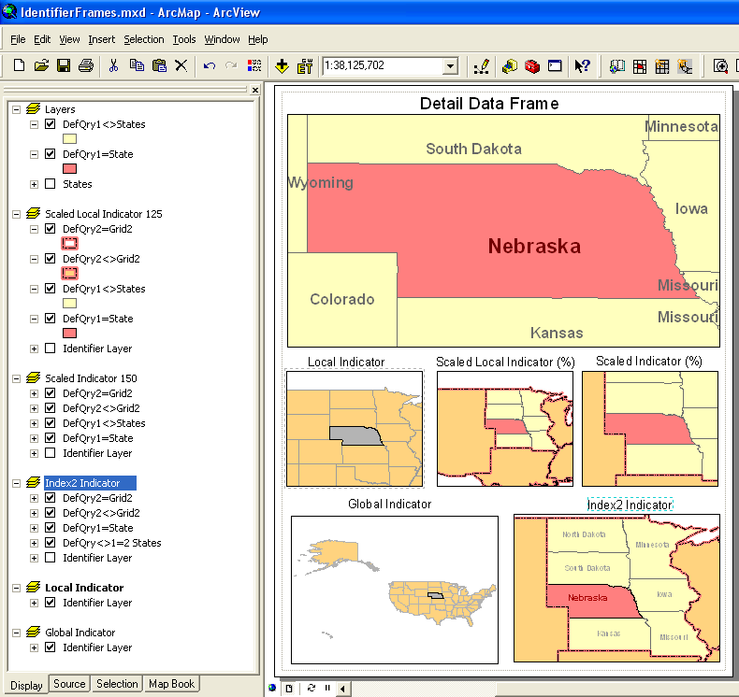
Grid 2 = Regions (grouping of States)

Setting Definition Query Options:

This feature enables control of the symbology and the labeling of features within and without of the extent of the tile in focus.

For primary index this functionality is dependent on two things:
1. The presence of the Index Field in the layer to receive the definition query (the field name and values must be the same as in the field selected to be the Index Field in the Index Layer).
2. The LayerName must begin with the Definition Query Label which may be followed with a descriptive name.

In order to utilize Index2 Definition Queries a field named Index2 must be present. The relationship between the primary index to index2 would be like County to State.
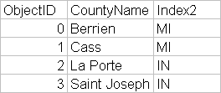
Example:

Primary Index Definition Query Label:
- DefQry1=LayerName (Filter for all records with Index = Tile in Focus)
- DefQry1<>LayerName (Filter for all records with Index<>Tile in Focus)

Index2 Definition Query Label:
- DefQry2=LayerName (Filter for all records with Index2 = Tile in Focus)
- DefQry2<>LayerName (Filter for all records with Index2<>Tile in Focus)
- DefQry<>1=2LayerName (Filter for all records with Index<> Tile in Focus AND Index2=Tile in Focus)

I have added some reminder helps on the DSMapBookUIPrj.vbp/frmPageIdentifier.frm (“Add Identifier Frame” button) so that mine now looks like this:

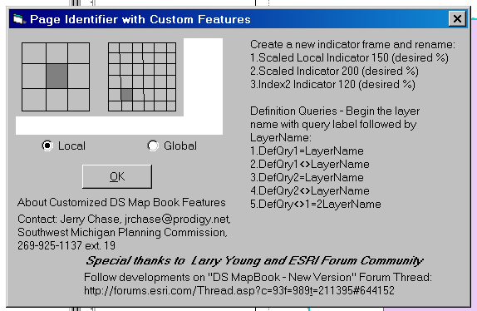

Changes saved in frmPageIdentifier.frm & frmPageIdentifier.frx
Code:
The code for these features were developed with the help from David Kimball, Forum Post re: DS Map Book (Map Series Layout), Oct 25, 2006 http://forums.esri.com/Thread.asp?c=93&f=989&t=64703&mc=308
And updated on February 22, 2007 with generous help from Larry Young

Posted to: Re: DS Map Book Custom Locator Frames & Definition Query, Aug 30, 2007, http://forums.esri.com/Thread.asp?c=93&f=989&t=64703#706998

For more information about DS MapBook
Current Discussion: http://forums.esri.com/Thread.asp?c=93&f=989&t=211395&mc=101
Site dedicated to ArcMapBook: http://arcmapbook.sourceforge.net/

Notes about compiling the code:
I have found the following steps are helpful in Compiling (recompiling) the DLLs.
1. Close ArcMap (& ArcCatalog) so that nothing has the DLL open
2. Save and Close the VB Project, then Reopen it
3. Compile DLL by choosing File/Make DSMapBookPrj.dll… (make sure that you don’t make any changes before compiling or you will need to Save & Close one more time.

‘Add Code in the following place: DSMapBookPrj.vbp/DSMapPage.cls/IDSMapPage/DrawPage

192: End If
'-------------------------------------------------------------------------
'-----Added JC February 21, 2007
SetDefQry pMap, m_sPageName, sIndex2, pSeriesProps 'Sets the Definition Query
'-----End Add
195: If bRefreshFlag Then

‘Add Code in the following place: DSMapBookPrj.vbp/DSMapPage.cls/General/RefreshIndicators

704: Set pActive = pDoc.Maps.Item(lLoop)
'-----Added JC February 21, 2007
SetDefQry pMap, m_sPageName, sIndex2, pSeriesProps 'Sets the Definition Query
'-----End Add
705: If bRefreshFlag Then pActive.Refresh

‘Add Code in the following place: DSMapBookPrj.vbp/DSMapPage.cls/General/RefreshIndicators

722: pActive.Extent = pEnv
'-----Added JC February 21, 2007
SetDefQry pMap, m_sPageName, sIndex2, pSeriesProps 'Sets the Definition Query
'-----End Add
723: If bRefreshFlag Then pActive.Refresh

'-----Added JC February 21, 2007
'Scaled Local Indicator JC February 21, 2007
10706: ElseIf Mid(pMap.Name, 1, 22) = "Scaled Local Indicator" Then
10707: Dim intP As Double 'Scale percentage
10708: intP = CDbl(NZ(Trim(Mid(pMap.Name, 23)), 100)) / 100
10709: Set pSpatial = New SpatialFilter
10710: Set pSpatial.Geometry = m_pPageShape
10711: pSpatial.GeometryField = pGridLayer.FeatureClass.ShapeFieldName
10712: pSpatial.SpatialRel = esriSpatialRelIntersects
10713: Set pCursor = pGridLayer.Search(pSpatial, False)
10714: Set pFeature = pCursor.NextFeature
10715: Do While Not pFeature Is Nothing
10716: If pEnv Is Nothing Then
10717: Set pEnv = pFeature.Shape.Envelope
10718: Else
10719: pEnv.Union pFeature.Shape.Envelope
10720: End If
10721: Set pFeature = pCursor.NextFeature
10722: Loop
10723: If intP > 0 Then pEnv.Expand intP, intP, True 'Expand the extent here
10724: Set pActive = pMap
10725: pActive.Extent = pEnv
10726:
10727: SetDefQry pMap, m_sPageName, sIndex2, pSeriesProps 'Sets the Definition Query
10728:
10729: If bRefreshFlag Then pActive.Refresh
'Scaled Indicator
20706: ElseIf Mid(pMap.Name, 1, 16) = "Scaled Indicator" Then
20707: intP = CDbl(NZ(Trim(Mid(pMap.Name, 17)), 100)) / 100 'intP = CDbl(Trim(Mid(pMap.Name, 17))) / 100
20708:
20709: Set pSpatial = New SpatialFilter
20710: Set pSpatial.Geometry = m_pPageShape
20711: pSpatial.GeometryField = pGridLayer.FeatureClass.ShapeFieldName
20712: 'Control the Extent with IEnvelope.Expand
20713: 'object.Expand (dx, dy, asRatio )
20714: Dim pGeom As IGeometry
20715: Set pGeom = m_pPageShape
20716: Set pEnv = pGeom.Envelope
20717: If intP > 0 Then pEnv.Expand intP, intP, True 'Expand the extent here
20718: Set pActive = pMap
20719: pActive.Extent = pEnv
20720: 'End Control the Extent
20721: '-----Added JC February 21, 2007
20722: SetDefQry pMap, m_sPageName, sIndex2, pSeriesProps 'Sets the Definition Query
20723: '-----End Add
20724: If bRefreshFlag Then pActive.Refresh

'Secondary Index Indicator, Code thanks to Larry Young, February 21, 2007
30706: ElseIf Mid(pMap.Name, 1, 16) = "Index2 Indicator" Then
30707: intP = CDbl(NZ(Trim(Mid(pMap.Name, 17)), 100)) / 100 'intP = CDbl(Trim(Mid(pMap.Name, 17))) / 100
30708: Dim pNewQuery As IQueryFilter
30709: Set pNewQuery = New QueryFilter
30710: 'Dim sIndex2 As String 'Cared for at the top of Sub
30711: 'sIndex2 = GetExtraItemValue(pDoc, m_sPageName, "", pSeriesProps) 'Cared for at the top of Sub
30712: If sIndex2 <> "missing" Then
30713: pNewQuery.WhereClause = " Index2 = '" & sIndex2 & "'"
30714: Set pCursor = pGridLayer.Search(pNewQuery, False)
30715: Set pFeature = pCursor.NextFeature
30716: Do While Not pFeature Is Nothing
30717: If pEnv Is Nothing Then
30718: Set pEnv = pFeature.Shape.Envelope
30719: Else
30720: pEnv.Union pFeature.Shape.Envelope
30721: End If
30722: Set pFeature = pCursor.NextFeature
30723: Loop
30724: Set pActive = pMap
30725: If intP > 0 Then pEnv.Expand intP, intP, True 'Expand the extent here
30726: pActive.Extent = pEnv
30727: If bRefreshFlag Then pActive.Refresh
30728: Else
30729: MsgBox "The Index2 field was not found in the attribute table of the Index Layer." & vbNewLine & vbNewLine & _
"The Index2 Indicator data frame option requires a secondary index field called Index2" & vbNewLine & _
" Ex: CountyName = Index Field (primary index), StateName = Index2 (secondary index)"
Exit Sub
30733: End If
SetDefQry pMap, m_sPageName, sIndex2, pSeriesProps 'Sets the Definition Query
30737: If bRefreshFlag Then pActive.Refresh 'End of JC February 21, 2007
'-----End Add
724: End If

‘Add Code in the following place: DSMapBookPrj.vbp/DSMapPage.cls/General/ add sub routine at the end of the class, below all other code

'-----Added JC February 21, 2007
Private Sub SetDefQry(pMap As IMap, m_sPageName As String, sIndex2 As String, pSeriesProps As IDSMapSeriesProps)
'Created by Jerry Chase, November 8, 2006 with help from David Kimball
'Forum Post re: DS Map Book (Map Series Layout), Oct 25, 2006
'http://forums.esri.com/Thread.asp?c=93&f=989&t=64703&mc=308
'Updated on February 22, 2007 with generous help from Larry Young
'Resets the definition query on any layer with name beginning with:
'"DefQry1=" or "DefQry1<>" and with a field equal to
'Grid Index field (Field Name and values must be the same)
'For DefQry1=LayerName = IndexField Value (for the Index Polygon)
'For DefQry1<>LayerName <> IndexField Value (for the Non-Index Polygons)
'Added DefQry2=,DefQry2<>, DefQry<>1=2 for a field named Index2 where IndexField is unique and Index2 is regional
'Ex: County=Index, State=Index2
On Error GoTo ErrHand:
Dim pFLayer As IFeatureLayer, pFLayerDef As IFeatureLayerDefinition, lLoop As Long

1200: For lLoop = 0 To pMap.LayerCount - 1
1201: If TypeOf pMap.Layer(lLoop) Is ICompositeLayer Then
1202: Set pFLayer = CompositeLayer1(pMap.Layer(lLoop), pSeriesProps.IndexLayerName)
1203: If Not pFLayer Is Nothing Then Exit For
Else
1205: If sIndex2 = "missing" And (Left(pMap.Layer(lLoop).Name, 11) = "DefQry<>1=2" Or Left(pMap.Layer(lLoop).Name, 7) = "DefQry2") Then
1206: MsgBox "The Index2 field was not found in the attribute table for layer DefQry..." & vbNewLine & vbNewLine & _
"Definition Query Labels DefQry2=, DefQry2<> and DefQry<>1=2 require a secondary index field called Index2." & vbNewLine & _
" Ex: CountyName = Index Field (primary index), StateName = Index2 (secondary index)." & vbNewLine & _
" Add a field named Index2 with the appropriate values and try again."
Exit Sub
End If
1211: If InStr(1, pMap.Layer(lLoop).Name, "DefQry1=", 1) > 0 Then
1212: Set pFLayer = pMap.Layer(lLoop)
'---Set the Definition query to Equal IndexField Value
1214: Set pFLayerDef = pFLayer
1215: pFLayerDef.DefinitionExpression = pSeriesProps.IndexFieldName & " = '" & m_sPageName & "'"
1216: ElseIf InStr(1, pMap.Layer(lLoop).Name, "DefQry1<>", 1) > 0 Then
1217: Set pFLayer = pMap.Layer(lLoop)
'---Set the Definition query to <> IndexField Value
1219: Set pFLayerDef = pFLayer
1220: pFLayerDef.DefinitionExpression = pSeriesProps.IndexFieldName & " <> '" & m_sPageName & "'"
1221: ElseIf InStr(1, pMap.Layer(lLoop).Name, "DefQry2=", 1) > 0 Then 'New Code, February 21, 2007
1222: Set pFLayer = pMap.Layer(lLoop)
'---Set the Definition query to = Index2 Value
1224: Set pFLayerDef = pFLayer
1225: pFLayerDef.DefinitionExpression = "Index2 = '" & sIndex2 & "'"
1226: ElseIf InStr(1, pMap.Layer(lLoop).Name, "DefQry2<>", 1) > 0 Then
1227: Set pFLayer = pMap.Layer(lLoop)
'---Set the Definition query to <> Index2 Value
1228: Set pFLayerDef = pFLayer
1229: pFLayerDef.DefinitionExpression = "Index2 <> '" & sIndex2 & "'"
1230: ElseIf InStr(1, pMap.Layer(lLoop).Name, "DefQry<>1=2", 1) > 0 Then
1231: Set pFLayer = pMap.Layer(lLoop)
'---Set the Definition query to <> IndexField Value and = Index2 Value
1233: Set pFLayerDef = pFLayer
1234: pFLayerDef.DefinitionExpression = pSeriesProps.IndexFieldName & " <> '" & m_sPageName & "'" _
& " AND " & "Index2 = '" & sIndex2 & "'"
1235: End If
1236: End If
1237: Next lLoop
1238: Exit Sub
1239:
ErrHand:
1241: MsgBox "SetDefQry - " & Erl & " - " & Err.Description
End Sub

Function NZ(val As Variant, retVal As Variant)
'Handy function to stop problems when Null values are passed in
'Note: You can't call the native Vb NZ function on ASP's
On Error Resume Next
If IsNull(val) Then
NZ = retVal
ElseIf val = "" Then
NZ = retVal
Else
NZ = val
If Err <> 0 Then
NZ = retVal
End If
End If
End Function
'-----End Add

Private Function GetAliasValue(pDoc As IMxDocument, sTileName As String, sFieldName As String, _
pSeriesProps As IDSMapSeriesProps) As String
'Adapted from GetExtraItemValue by Jerry Chase, February 25, 2007
'This doesn't seem to work under its current logic
On Error GoTo ErrHand:
MsgBox "Begin GetAliasValue"
Dim pIndexLayer As IFeatureLayer, pQuery As IQueryFilter, pFCursor As IFeatureCursor
Dim pFeat As IFeature, lIndex As Long, pMap As IMap, lIndex2 As Long

'Find the data frame
792: Set pMap = FindDataFrame(pDoc, pSeriesProps.DataFrameName)
793: If pMap Is Nothing Then
794: MsgBox "Could not find map in GetExtraItem routine!!!"
795: GetAliasValue = "missing"
Exit Function
797: End If
MsgBox "GetAliasValue Line 797:"
'Find the Index layer
800: Set pIndexLayer = FindLayer(pSeriesProps.IndexLayerName, pMap)
801: If pIndexLayer Is Nothing Then
802: MsgBox "Could not find index layer (" & pSeriesProps.IndexLayerName & ") in GetExtraItemValue routine!!!"
803: GetAliasValue = "missing"
Exit Function
805: End If
MsgBox "GetAliasValue Line 805:"
'Find the field in the index layer
'808: lIndex = pIndexLayer.FeatureClass.FindField(sFieldName)

Dim pFields As IFields
Dim pField As IField

'Get Fields
'Set pFields = pFeatClass.Fields
Set pFields = pIndexLayer.FeatureClass.Fields
'Find the field with the aliasname "current population"
'i = pFields.FindFieldByAliasName("current population")
'Set the current field
'Set pField = pFields.Field(i)

808: lIndex = pFields.FindFieldByAliasName(sFieldName)
809: If lIndex < 0 Then
810: If sFieldName <> "Index2" Then MsgBox "Could not find the field (" & sFieldName & ") you tagged the item with in the index layer!!!"
811: GetAliasValue = "missing"
Exit Function
813: End If
MsgBox "GetAliasValue Line 813: and lIndex = " & lIndex
'Find the tile name field in the index layer
816: lIndex2 = pIndexLayer.FeatureClass.FindField(pSeriesProps.IndexFieldName)
817: If lIndex2 < 0 Then
818: MsgBox "Could not find tile name field (" & pSeriesProps.IndexFieldName & ") in the index layer!!!"
819: GetAliasValue = "missing"
Exit Function
821: End If
MsgBox "GetAliasValue Line 821:"
'Create the query object then select the appropriate tile from the index layer
'Will Alias Name work in query???

824: Set pQuery = New QueryFilter
825: pQuery.WhereClause = pSeriesProps.IndexFieldName & " = '" & sTileName & "'"
826: Set pFCursor = pIndexLayer.Search(pQuery, False)
827: Set pFeat = pFCursor.NextFeature
828: If pFeat Is Nothing Then
829: MsgBox "Could not select the tile from the index layer to tag with Extra Item!!!"
830: GetAliasValue = "missing"
Exit Function
832: End If
MsgBox "GetAliasValue Line 832:"
'Send back the value of the field
835: If IsNull(pFeat.Value(lIndex)) Then
836: GetAliasValue = " "
837: Else
838: GetAliasValue = pFeat.Value(lIndex)
839: End If
MsgBox "GetAliasValue = " & GetAliasValue
Exit Function
ErrHand:
843: MsgBox "GetAliasValue - " & Erl & " - " & Err.Description
End Function

‘End of Customized DS Map Book Code
‘Document last edited September 28, 2007
‘Jerry Chase, jrchase@prodigy.net

XXXXXXXXXXXXXXX Previous Code XXXXXXXXXXXXXXXX

Here is one solution for controling the Labels and Symbology of the Index Polygon and those outside the Index Polygon. This solution updates the definition query to specific layers whose names begin with a specific string.
* Layer Names that begin with “ClipDefQry” = Index Field Value (for the Index Polygon)
* Layer Names that begin with “ExcludeDefQry” <>Index Field Value (for the Non-Index Polygons)
Any layer that starts with “ClipDefQry” or “ExcludeDefQry” may be used as long as it has the same field (same name and values) used for the Index in the Grid layer.
As always, share your suggestions and improvements!

‘The code will be inserted as indicated. New Code is indicated by '-----Added JC November 8, 2006 before and '-----End Add after

‘Add Code in the following place: DSMapBookPrj.vbp/DSMapPage.cls/IDSMapPage/DrawPage
192: End If
'-------------------------------------------------------------------------
'-----Added JC November 8, 2006
SetDefQry pmap, m_sPageName, pSeriesProps 'Sets the Definition Query
'-----End Add
195: If bRefreshFlag Then 'Moved to below Update Definition Query
196: pDoc.ActiveView.Refresh
197: End If

‘Add Code in the following place: DSMapBookPrj.vbp/DSMapPage.cls/General/RefreshIndicators
704: Set pActive = pDoc.Maps.Item(lLoop)
'-----Added JC November 8, 2006
SetDefQry pmap, m_sPageName, pSeriesProps 'Sets the Definition Query
'-----End Add
705: If bRefreshFlag Then pActive.Refresh

‘Add Code in the following place: DSMapBookPrj.vbp/DSMapPage.cls/General/RefreshIndicators
722: pActive.Extent = pEnv
'-----Added JC November 8, 2006
SetDefQry pmap, m_sPageName, pSeriesProps 'Sets the Definition Query
'-----End Add
723: If bRefreshFlag Then pActive.Refresh

‘Add Code in the following place: DSMapBookPrj.vbp/DSMapPage.cls/General/ add sub routine at the end of the class, below all other code

Private Sub SetDefQry(pmap As IMap, m_sPageName As String, pSeriesProps As IDSMapSeriesProps)
'Created by Jerry Chase, November 8, 2006 with help from David Kimball
'Forum Post re: DS Map Book (Map Series Layout), Oct 25, 2006
'http://forums.esri.com/Thread.asp?c=93&f=989&t=64703&mc=308
'Resets the definition query on any layer with name beginning with:
'"ClipDefQry" or "ExcludeDefQry" and with a field equal to
'Grid Index field (Field Name and values must be the same)
'For ClipDefQry = IndexField Value (for the Index Polygon)
'For ExcludeDefQry <> IndexField Value (for the Non-Index polygon)
On Error GoTo ErrHand:
Dim pFLayer As IFeatureLayer, pFLayerDef As IFeatureLayerDefinition
Dim lLoop As Long ', pEnv As IEnvelope, lIndex As Long

1206: For lLoop = 0 To pmap.LayerCount - 1
1207: If TypeOf pmap.Layer(lLoop) Is ICompositeLayer Then
1208: Set pFLayer = CompositeLayer1(pmap.Layer(lLoop), pSeriesProps.IndexLayerName)
1209: If Not pFLayer Is Nothing Then Exit For
Else
1211: If InStr(1, pmap.Layer(lLoop).Name, "ClipDefQry", 1) > 0 Then
1212: Set pFLayer = pmap.Layer(lLoop)
'---Set the Definition query to Equal IndexField Value
1214: Set pFLayerDef = pFLayer
1215: pFLayerDef.DefinitionExpression = pSeriesProps.IndexFieldName & " = '" & m_sPageName & "'"
1216: ElseIf InStr(1, pmap.Layer(lLoop).Name, "ExcludeDefQry", 1) > 0 Then
1217: Set pFLayer = pmap.Layer(lLoop)
'---Set the Definition query to <> IndexField Value
1219: Set pFLayerDef = pFLayer
1220: pFLayerDef.DefinitionExpression = pSeriesProps.IndexFieldName & " <> '" & m_sPageName & "'"
1221: End If
1222: End If
1223: Next lLoop

Exit Sub
ErrHand:
1227: MsgBox "CompositeLayer - " & Erl & " - " & Err.Description
End Sub

